Wendy Groff-Otto
EC – 6 Elementary School Teacher
Elementary
11/1/2018

Classroom Management Plan
Discipline Philosophy
I believe classroom management and discipline plans should be communicated and agreed on early in the school year. Rules and expectations need to be clearly communicated, demonstrated and practiced by the students so they are adhered to throughout the school year. This will make our school year run smoothly so we can focus on learning.
See Trifold attachment.
Classroom Management
Arrival: Students are expected to be in their seats when the bell rings at 8:00am. Students can arrive no earlier than 7:30am unless they are in the before school program which is located on the south side of the building in the cafeteria. Students are expected to stay in the building until classes end at 3:30. Upon arrival to the school, students are expected to go to their lockers and put up any personal belongings not required for the morning classes, line up to enter their homeroom class and enter when instructed by the teacher.
Tardy: A student is tardy to class if he/she comes into the classroom any time after the bell rings for the start of that class. If you are tardy please go directly to the attendance office and obtain a tardy slip. Bring tardy slip into class room and put it in the basket just inside the classroom door. Proceed to your seat quietly and start working. Tardy slips will become part of the students file. After the third tardy and any occurrences thereafter, the student will serve a 30 minute detention afterschool in room 303. Habitual occurrences will require a parent/teacher/principal conference to be held and documented.
Absence: If you are going to be absent from school have parent/legal guardian call the attendance clerk at 817-717-7000 to report the absence. Visit our class weebly page at wendygroff.weebly.com to request make up work. You will have one school day to complete missing work. Failure to complete make up work will result in a zero for each missed assignment. It is your responsibility to request and make up missed assignments due to an absence.
Homework: Although most of our work will be done in the classroom, I will be assigning material to be completed at home regularly. Please place your homework assignment in the homework basket just inside the door upon entering the classroom. Late assignments will not be accepted. Please note if you are having trouble completing your homework assignment, try the links located on our class weebly page, try the best you can and hand it in. On the top of the homework page write ‘trouble’ and I will arrange for one on one time to clarify it. Do NOT hand in any assignment blank you will not get credit for it.
Getting the Class' Attention: To get the students attention or have them quiet and/or settle down: I will use the ‘give me five’ method. I will raise my hand and say give me five. Each of the students in the classroom will in turn raise their hand and quiet down this will be done until all students have settled and have hand in air. If the class is too loud and the ‘give me five’ method is not working I will play a clip of a song quite loudly to get their attention and ask them to quiet down and pay attention.
Visitor in the Room: I will introduce any visitors who come into the classroom, explain why they are there and remind the students not to speak unless spoken to.
Getting the Teacher's Attention: Students are to raise their hand if they have a question. At no time should the student go to the teacher’s desk to ask a question unless they were told to or it is an emergency.
Restroom: We have regularly provided bathroom breaks throughout the day. If for some reason you need to use the restroom during class please raise your hand and wait to be called on.
Lining Up/Hallway: At the beginning of each week I will designate a line leader, it’s the line leader’s responsibility is to lead us to our intended destination quickly and quietly. You are to line up in the front of the classroom by table numbers. In the hallway students are to walk quietly in a straight line with your hands at your sides.
Collaborative Group Work: This class will have plenty of collaborative group work. I will assign who your partners will be, how many will be in a group and what lesson will be conducted as collaborative efforts. Students should collaborate in a respectful manner. All students are required to actively participate in group work keeping voices at a low volume.
Transition: Two minutes before the bell rings pack up your things and clean up your area. When the bell rings go quickly to your next class. Do not linger in hallways.
What To Do When Done: When you have finished your work recheck it once more, turn it over and leave it turned upside down in the middle of the desk to be picked up by teacher. If you are done before everyone else get out your chrome book and do an assignment on it. If no assignments are available ask the teacher, do your homework or read your library book.
Dismissal: Two minutes before the bell rings pack up your things and clean up your area. . Look at assignment sections on the board if all assignments have not been completed bring them home for homework. When the bell rings go to your designated pick up spot. ( Front of the building for parent pick up, the back of the building for buses) Do not linger in hallways.
Home and School Connection: Visit our class website at https://wendygroff.weebly.com for assignments, up-coming projects, announcements and other important class information. For homework help post a question on our Google + community. Sign up for text reminders. Follow us on twitter #austinblueroos, #msgroffsroos or join us on facebook! Ms Groff’s Roos. You can contact me directly through the class website, by calling the school at 817-717-7000. I will try to return any messages within 24 hours.
Bullying Pledge: We will conduct an anti-bullying lesson the first week of school that introduces bullying, included in the lesson will be Burger King’s bullying Jr. YouTube video https://youtu.be/mnKPEsbTo9s , they will complete the anti-bullying pledge at https://pacer.org and receive a certificate.
As a Kid Against Bullying, I pledge to:
- Speak up when I see bullying.
- Reach out to others who are bullied.
- And be a friend whenever I see bullying.
We will review steps to take if you are bullied or if you see someone being bullied. They include:
- If the student is being bullied: contact teacher, parent or adult and explain to them what is going on, who is involved and who might have witnessed the bullying.
- If you see someone being bullied: Go get help from an adult, don’t participate or instigate in bullying, ask the person being bullied if they are Ok and be a friend to them.
- If a parent suspects their child is being bullied: Contact the teacher, school administration or counselor so the problem can be investigated and addressed properly.
Teach Procedures: It is the teacher’s job to be a role model for his/her students. I will demonstrate and model procedures expected of students in the classroom. Next, we will rehearse these procedures by role playing using the games mentioned in this youtube video https://youtu.be/kF4qKbVFR0s. Behavior modifications will involve modeling bad behavior vs good behavior. I will evaluate the student’s role play making sure they understand what is expected of them. If any confusion occurs I will adjust the lesson and restate the expectation in another way then repeat the process above. I will reinforce the instruction by giving positive praise to those students that demonstrate the correct procedures and individual help to those that have not yet grasped the concept.

Discipline Plan/Classroom Rules
Accountability – On the first day of school I will review the rules with the class and give them the opportunity to remove or add rules they deem important. These rules will be on a poster board that will be affixed to the bulletin board visible to all students everyday throughout the year. The students will sign the poster acknowledging that they reviewed and understand the classroom rules and will serve as our negotiated contract. I will send home our classroom management plan and request a signed acknowledgement be sent back to the school from a parent/guardian.

Rules – Some of our rules are listed below.
- Be on time, seated and have materials needed for learning out on the desk before the late bell rings.
- Be polite and courteous to all members of the class and the teacher.
- Raise your hand and wait to be called upon before speaking.
- Turn in all work complete and on time, in the appropriate place, with name, date and period on it.
- Obey all school rules regarding behavior and dress.
- Don’t give up!

Discipline – I will use a discipline plan that starts with a verbal warning and ends with last step being sent to the office. It will be fair and enforced consistently. A behavior log will be kept up to date for each student.

Consequences – I have set up a six step process if rules are broken. (Unless the child’s behavior is threatening, dangerous or severely disruptive that will escalate to step immediately.)
- Verbal warning
- Name on board
- Checkmark by name and 30min detention to be served before or after school the following day.
- Another checkmark and a class period in in-school detention
- Third checkmark, phone call home, parent/teacher/student conference.
- Go to the principal’s office, phone call home.
Rewards – I will be praising and handing out fake money to students throughout the school year when they exhibit positive behavior. Once a month, the student’s will have the opportunity to use their fake money to buy from the class store during 6th and 7th period. The class store consists of snacks, drinks and common school items. (Items: pens, pencils, paper, notebooks and other goodies.)

Seating

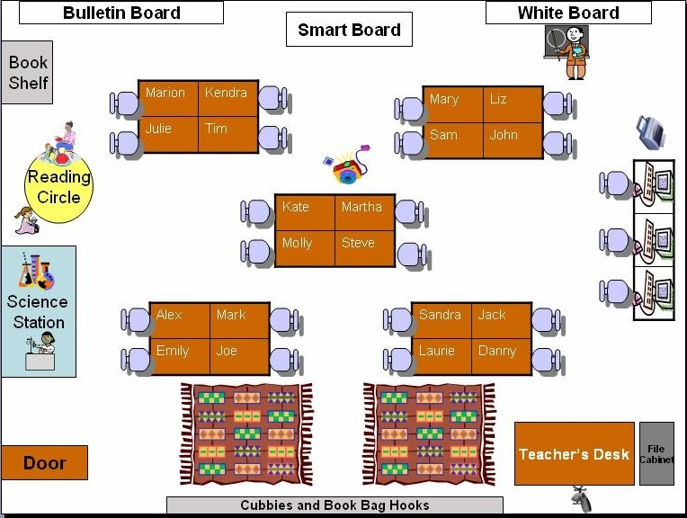

Student desks: The student’s desks are grouped in sets of four which is more conducive to cooperative learning. The assigned seats will change throughout the year promoting collaboration with everyone in the class. Students are welcome to move about the classroom and collaborate in pairs/groups on rugs, at science station, at computers or in reading area.
Teacher’s desk: The teacher’s desk is off in the corner opposite the learning area of bulletin, smart and dry erase boards. It will be used more for storage/organization then utilized by the teacher while class is in session.
Seating Assignment Method
Students will be assigned seats using a name tag method. All tables will also be labeled 1 – 5 making it easier to have the group move from place to place, participate in assignments/collaborations and line up for class changes and dismissal.

Letter of Introduction to Students
Preparation

Dear Jimmy Smit,

My name is Ms. Groff and I am very excited to be your 5th grade math/science teacher this year at Stephen F Austin Elementary. I can’t wait to meet you and am looking forward to having you in my class! I have some special projects planned for us! I am planning a year filled with fun and exciting lessons and cannot wait to share them with you!

I have always wanted to teach 5th grade. So you know a little about me, my hobbies are gardening, camping, fishing and yoga. I live out in the country and have four grown children, a grandson that is 3 years old, 5 dogs and 6 cats.

I hope you are ready to have fun learning this year!

Sincerely,

Ms. Groff
Room 122 Stephen F Austin Elementary

Letter of Introduction to Parents

Dear Mr.& Mrs. Smit,

My name is Ms. Wendy Groff. I will be your child’s 5th grade math/science teacher at Stephen F Austin Elementary. I am currently working to obtain my master’s degree in education at Tarleton State University. I am new to Stephen F. Austin and am excited about the opportunity to work in such a high achieving school that supports parental and community involvement.

This year will be a very exciting! I have various lessons planned that will be implemented in a positive learning environment that fosters communication and social skills. I have high expectations that your child will grow academically, socially and emotionally in my classroom. Our cooperative learning environment keeps them moving, engaged and socially active every day.

In the unlikely event that a disciplinary issue arises, I have set up a six step process if rules are broken.
- Verbal warning
- Name on board
- Checkmark by name and 30 minute detention to be served before or after school the following day.
- Another checkmark and a class period in in-school detention
- Third checkmark, phone call home, parent/teacher/student conference.
- Go to the principal’s office, phone call home.

I would like to have a transparent classroom so it is open to you any time you care to visit. I will be asking for volunteers throughout the year to help out during tutoring classes, special projects and other times as needed. If you are unable to come in during school hours, I have other opportunities available for you to help. My conference period is from 10:00 – 10:45 Monday – Thursday. I am available by phone, appointment and video conferencing. Please feel free to call me at (817)598-2848 or through my contact email on our weebly class website. http//:wendygroff.weebly.com.

I am looking forward to meeting you at our up-coming Meet the Teacher Night!

Sincerely,

Ms. Wendy Groff – 5th grade teacher
Room 122 Stephen F Austin Elementary

Tentative Agenda/Schedule for the 1st Day

Before school starts – Place name cards on desk, lesson of the day written on the board, class schedule hung up, bell work assignment on desk. (A class)
8:00 - 8:20: Greet students at door (smile, name, hand shake), Tell them where to put their things, have them find name tag and take a seat, start on bell assignment.
8:20 – 8:40: Welcome students as a group to the class, take attendance / send sheet to office, have students finish up bell assignment.
8:40 – 9:05: Share welcome/introduction PowerPoint. Do ice breaker, have students share things about themselves.
9:05 – 9:50: Go over classroom management procedures – demonstrate/role play.
9:50 – 10:00: Take a bathroom break – reiterate procedures for lining up, hallways.
10:00 – 10:45: Negotiate rules have students put on poster board – all sign when completed.
10:45 – 11:00: Practice/discuss classroom management procedures again.
11:00 – 11:45: Lunch time (A and B classes switch)
11:45 – 12:05: Greet students at door (smile, name, hand shake), Tell them where to put their things, have them find name tag and take a seat, start on bell assignment.
12:05 – 12:30: Welcome students to class as a group. Take attendance/ send sheet to office. Share welcome/introduction PowerPoint. Do ice breaker, have students share things about themselves.
12:30 – 1:15: Go over classroom management procedures – demonstrate/role play.
1:15 – 1:25: Take a bathroom break – reiterate procedures for lining up, hallways.
1:25 – 2:10: Negotiate rules have students put on poster board – all sign when completed.
2:10 – 2:25: Practice/discuss classroom management procedures again.
2:25 – 3:15: Review/demonstrate Kagan partner pairing scenarios.
3:15 – 3:20: Clean up, pack up for home, line up to leave based on way home chart.

First Day Bell Work Assignment
I will distribute an index card that will be filled out by the student allows me to get to know them. It will ask for name, what they want to be called, parents phone number, birthday, age, favorite color, favorite food and hobbies. I will have a writing prompt at the bottom that asks them to name three unique things about themselves. I will file these in index card file for reference throughout school year.
See attached.

Professional Presentation
Teacher Welcome/Introduction
See PowerPoint presentation

_

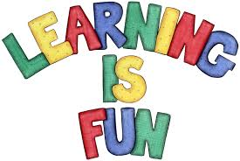
Preparation Checklist

A checklist of things to have done before the students arrive to your classroom.

Classroom
Room decorated: (lessons for the day, student section)
Files organized : (student files, lesson plans, other documents)
Tubs filled with lesson plans for the week: (Monday thru Friday)
Lesson of the day written on board
Assignments/class news written on board
Bullying pledge hung
Class schedule
Desks arranged and name tags placed on desks
Bell work assignment
Turn on all computers/lights
Discipline plan
Class rules and procedures

School departure list : (pick up, bus, walk, afterschool program)

On the first day of school, I will stand in class entry way, smiling, and greet each student as they arrive to the classroom, shaking student’s hand, asking their name and saying “Welcome, I am so glad I have you in my class this year!

Every day of the school year, I will greet the students at the door confident, smiling and starting off the day on a positive note. I will come up with new scripted questions so that the greeting doesn’t become a boring repetitious event. After getting to know the students I will assign a student greeter to greet their classmates with me for a week. I will be rotating student greeters throughout the school year.

Bell Assignment

Write on index card

Full Name: Name you would like to be called:

Parents phone #:

Birthday: Age:

Favorite color: Favorite food:

Hobbies:

3 Unique things about yourself:

